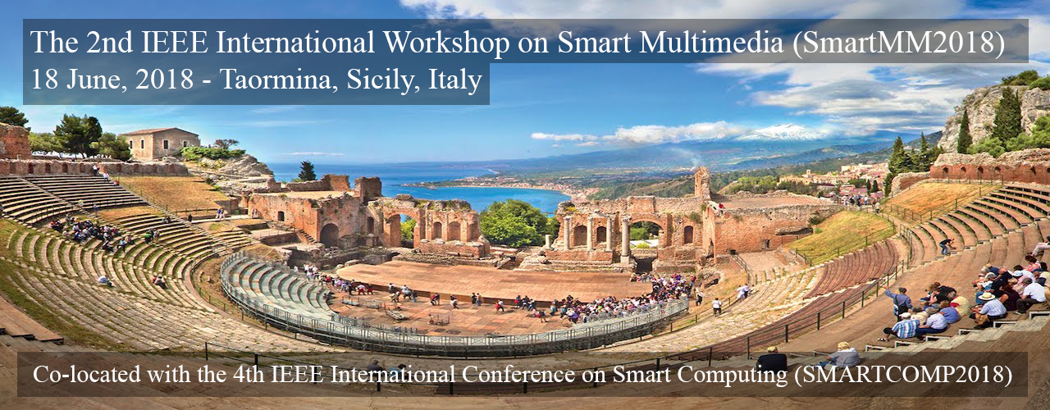

**CALL FOR PAPER**

Multimedia application is among the most intensive systems in the internet. Rich content and latency intensive features of multimedia requires sophisticated infrastructure support from cloud, network, and terminals. Smart service system, the emerging topic, should be explored for improving human experience in multimedia applications.

The 2018 IEEE International Workshop on Smart Multimedia (SmartMM2018) focuses on smart technologies in multimedia system and applications. The SmartMM2018 will be in conjunction with the 4th IEEE International Conference on Smart Computing (SmartComp2018) on 18-20 June, 2018.

The topics to be addressed at SmartMM2018 will include, but are not limited to, all aspects of smart computing applications and technologies regarding multimedia system. We encourage submissions that showcase fundamental research to address challenges in enabling smart multimedia. Submissions should be targeted to one of the following four major topics and their sub-topics:

* **Measurement and Modeling**
  + QoS measurement in smart multimedia applications
  + QoE modeling in smart multimedia applications
  + User behavior analysis and prediction in smart multimedia applications
* **Design and Implementation**
  + Architecture of network caching for smart multimedia
  + Named data network (NDN) for smart multimedia
  + Software-defined networks for smart multimedia
  + Smart device-to-device (D2D) sharing for multimedia
  + Novel architecture and engineering approach in smart multimedia
* **System Optimization**
  + Smart resource allocation in multimedia applications
  + Smart task scheduling for multimedia applications
  + QoE-oriented optimization in smart multimedia application
  + Cognitive service integration in multimedia applications
* **Emerging Smart Multimedia Applications**

**IMPORTANT DATES**

**Paper Submission Deadline**

**28 February 2017**

**Acceptance Notification**

30 March 2017

**Camera Ready Deadline**

21 April 2017

**CONTACTS**

**Workshop Website**

[**http://www.smartmm.org/**](http://www.smartmm.org/)

**Contact Email**

[**smartmm2018@gmail.com**](mailto:smartmmhk@gmail.com)

**ORGANIZING COMMITTEE**

**Victor C.M. Leung**

The University of British Columbia, Canada

**Wei Cai**

The University of British Columbia, Canada

**Zhi Liu**

Shizuoka University, Japan

**Zehua Wang**

The University of British Columbia, Canada

**Han Hu**

Nanyang Technological University, Singapore

**Qiang Liu**

National University of Defense Technology, China

***All presented papers will be appeared in the IEEE Xplore Digital Library and will be EI indexed.***

**SUBMISSION GUIDELINES**

Paper submissions should be ***no longer than 6 pages*** and formatted according to the IEEE conference template. Papers must be submitted electronically as PDF files to ***SmartMM2018 track*** at SmartComp2018 through EasyChair at:

<https://easychair.org/conferences/?conf=smartcomp2018>